Lecture 9 (Nov 9, 2020)

Assignment 9

Quiz #4 (Nov 13-15) (primarily linear models and regression)

Homework (all for stock data)

1. linear/quadratic discriminant xxx
2. decision tree
3. random forest
4. adaboost (optional ….)

Nov 16, 23, 30

Project Presentations: Dec 7

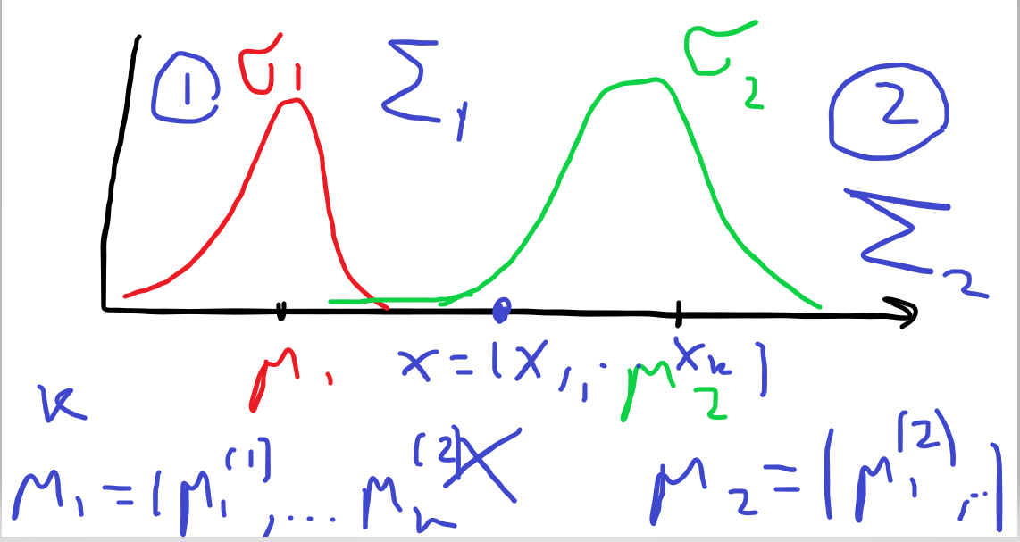

log_reg.coef_

For part 1 just get the coefficients ….

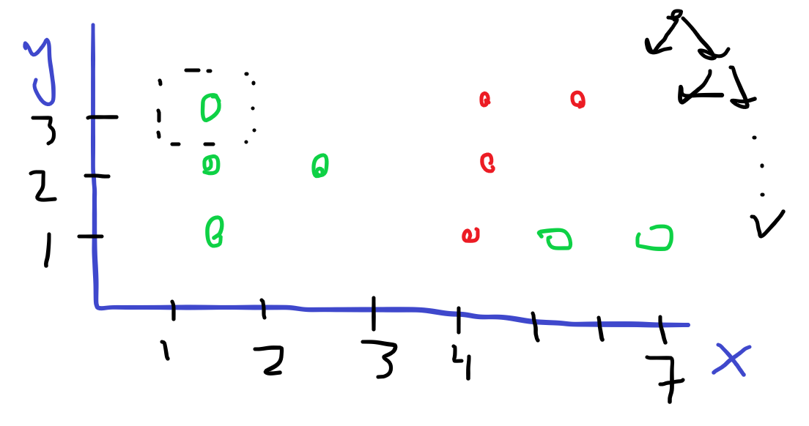

In decision tree we want to construct “flow chart” in such a way as to minimize the average number of steps from root to leaves.

How do we choose what feature to use for splitting? Answer: use “entropy”

STAY HEALTHY AND WELL

SEE YOU NEXT WEEK!